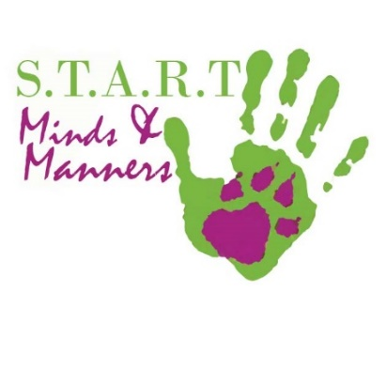
TRAINING and PARTICIPATION CONTRACT
Agreement of Release & Waiver of Liability

Between Black Ridge and The Participant for any event or
dog training organized by Black Ridge and/or Sport Dog Training Center,
held at any location in Ontario, Canada

THE PARTICIPANT INFORMATION:
Handler Name: Type in Your Name Here Dog Name: Type Dog’s Name Here
Address: Enter Your Address
City: Enter Your City Postal Code : Type Your Postal Code
Enter a contact phone number incase of Cancelations: Type Your Contact Phone Number

Email: Enter your Email Here I would like to Receive The Newsletter ☒

My dog has Bit, lunged at, or Attacked a Dog or Person after 4 months of age: Yes No
My dog has never lunged, or barked at, chased, or bitten another dog: Yes No

I, the Owner, agree to the following Commitment: I am making a commitment to using only positive training methods, and that dog training is a process. My dog will learn as fast as I teach it. And that my frustration and lack of daily commitment can set back my dog’s progress. I will engage in any activity needed to reach my ultimate goal including, daily play, and a minimum of 2x 5 minutes training sessions a day.

I understand that it is important to have a unified family approach. Inconsistency will create confusion in a dog and can cause serious disconnects, which may cause aggression and nervous problems with my dogs. I also agree not to use any punitive or aversive correction methods after training has begun.

I agree that I need to take responsibility for my dog’s level of success. I have the power to teach my dog to behave as a well-mannered, controllable member of my family. I understand that dog training is not about demanding a specific response to stimuli, but building a relationship of trust and respect which earns my dog’s obedience.

I understand that there is no guarantee that training or behavior programs will change my dog’s behavior. I also understand that most dogs need more than 1 obedience program before I will see a dramatic change in my dog’s behavior. I also understand that if I don’t change the dog’s environment, lifestyle, and practice 2 – 10 times a day, there will be no change in my dog’s behavior.

I agree: Missing a session without 24 hours notification may result in forfeit of the lesson without a refund. Arriving late shortens that lesson without refund of cost. Missing 2 sessions without notification constitutes cancellation of contract. You may reinstate the contract at a future date, at the convenience and availability of a suitable trainer.

- Positive Transformation | - START Full Puppy Program $255 | - K9Klub 10x $99
- PT - Practice | - START Great Beginnings | - Freestyle Dance/Rally Free
- Working Breed Puppy | - START Smart Pup | - Scent
- Working Breed $295 | - CLASS $99 | - Jump and Contact Agility

Cost: __________ Sessions/Duration: _____________ Scheduled Time: _______________Payments: ________________

Expectations and Limitations(if any): ________________________________________________________________________

By signing I consent to the terms and conditions in this Training Agreement and all Waivers:

Click arrow to Select Date Print Your Name ________________________________
DATE SIGNATURE or E-SIGNATURE OF THE PARTICIPANT

Click Arrow to Select Date Print Your Name _________________________________________________
DATE SIGNATURE or E-SIGNATURE OF THE PARTICIPANT

If handler is under 18 years of age: I sign as legal guardian of ______________________________________
SIGNATURE or E-SIGNATURE OF THE PARTICIPANT

Click Arrow to Select Date Print Your Name _________________________________________________
DATE SIGNATURE or E-SIGNATURE OF THE TRAINER

