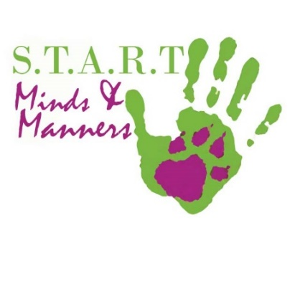
TRAINING and PARTICIPATION CONTRACT
Agreement of Release & Waiver of Liability

Between Black Ridge and The Participant for any event or
dog training organized by Black Ridge and/or Sport Dog Training Center,
held at any location in Ontario, Canada.

THE PARTICIPANT INFORMATION:
Handler Name: Type in Your Name Here Dog Name: Type Dog’s Name Here
Address: Enter Your Address
City: Enter Your City Postal Code : Type Your Postal Code
Enter a contact phone number incase of Cancelations: Type Your Contact Phone Number

I (We), The Participant, hereby agree to the following:
1. I understand that attendance of a Sport Dog Training Center (owned by Black Ridge) class or event is not without risk to myself, members of my family or guests who may attend, or my dog, because some of the dogs which I (We) will be exposed may be difficult to control and may be the cause of injury even when handled with the utmost care.
2. I represent and warrant that my dog is physically fit and has no medical condition which would prevent his full participation in any Sport Dog Training Center’s activities. I agree to bring my dog clean and free of fleas and parasites before the first day of class along with proof that my dog has received a minimum of two out of four vaccinations. These vaccinations are to remain current throughout the duration of classes. I understand that dogs pick up viruses, parasites, and bacteria from a variety of environments and agree not to hold Black Ridge, Sport Dog Training Center, or its owners and employees responsible for my dog’s health.
3. In consideration of my dog being permitted to participate in activities organized by Sport Dog Training Center or Black Ridge, I agree to assume full responsibility for any risks, injuries or damages, known or unknown, which might incur as a result of me and my dog participating in Sport Dog Training classes. As is in accordance with Ontario Law.
4. In further consideration of my dog being permitted to participate in Sport Dog Training Center events or training, I knowingly, voluntarily and expressly waive any claim I may have against Sport Dog Training Center, or Black Ridge (including its employees, owners and agents) for injury or damages which I or my dog may sustain as a result of participating in these events or dog training. I hereby waive and release Sport Dog Training Center, Black Ridge (including its employees, owners and volunteers) from any and all liability of any nature or damage which I or my dog may suffer, including specifically, but not without limitation, any injury or damage resulting from action of any dog, and assume risk of any such damage or injury while attending any training session held by Sport Dog Training Center or Black Ridge.
I accept responsibility for, and compliance to the following:
- Dogs that attempt to bite another are to be removed from a class immediately. Unless Entered in an appropriate class
- There is no tolerance of abuse. Any use of physical force, including, but not limited to choking, striking, electrical shock, or any act meant to cause fear or pain to a dog, will result in my immediate expulsion from class. No refund is awarded. Student may be reinstated if they agree to use only positive training methods.
- Anyone permitting their dog to bully or threaten another dog without immediately removing their dog and then bringing it under control will remove themselves from all areas where other dogs are congregated. If they do not, all measures will be taken to protect the other dogs in the vicinity, including expulsion from class.
5. I, my heirs or legal representatives’ forever release, waive, discharge and covenant not to sue Sport Dog Training Center, or Black Ridge (including its employees, owners and agents) for any loss, injury or death caused by their negligence or other acts during the training of my dog or while on route to, or on the training premises, or any location in Ontario.
6. Sport Dog Training Center reserves the right to refuse service to anyone. Children under the age of 18 years must be accompanied by an adult. Junior handlers must be at least 10 years old.
7. The payment is non-refundable after a first lesson, and if a check is returned from the bank, I agree to pay a $45.00 returned check fee. I may resume lessons within 6 months of quitting with written notice to info@sportdogtrainingcenter.com

By signing I consent to the terms and conditions in this Training Agreement and all Waivers:

Click to Select Date Print Your Name ________________________________
DATE SIGNATURE or E-SIGNATURE OF THE PARTICIPANT

Click to Select Date Print Your Name _________________________________________________
DATE SIGNATURE or E-SIGNATURE OF THE PARTICIPANT

If handler is under 18 years of age: I sign as legal guardian of ______________________________________

_______________ _______________________________________________________
DATE SIGNATURE OF TRAINER

